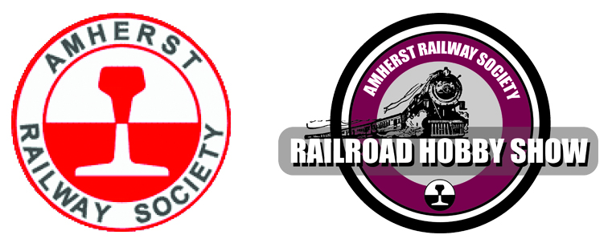
PO Box 247, Monson, MA 01057

Liability Insurance – 2023 Amherst Railroad Hobby Show

It has come to a point in time when we must consider the Amherst Railroad Hobby Show as a business and with that comes concerns with liability and liability insurance issues.

The Amherst Railway Society has changed to a new Insurance carrier and provider. They have required us to obtain Liability Insurance coverage from all of our 2023 Amherst Railroad Hobby Show Vendors.

We have compromised to make this as easy and low-cost to our Vendors and Exhibitors as possible. The following two (2) options are available:

- If you already have existing Liability Insurance Coverage, or if you want to purchase your own, request a certificate of insurance from your Provider, request them to make Amherst Railway Society Inc. and Eastern States Exposition as an additional insured, and mail us a copy.

- To all Non-Profit, Tax Exempt Vendors and Vendors/Exhibitors who sell only occasionally at Hobby Shows; If you do not want Liability Insurance, please sign the attached waiver/Hold Harmless form and return to the Amherst Railway Society Inc.

If you have any questions, please contact Meaghan Royce, Show Office Manager, Amherst Railway Society Inc., P O Box 247, Monson, MA 01057-0247, Telephone 413-267-4555, E-Mail: showoffice@amherstrail.org.

Phone:  413-267-4555 | E:mail:  Showoffice@amherstrail.org | Web:  http://www.amherstrail.org

